Architecture Design
for
Brew Day
Version 2.0 approved
Prepared by Yuanzhen Lin, Xiaochen Xu, Ziqi Wang, Weifeng Huang
Gray
2019/05/23
Table of Contents
Table of Contents ii
Revision History ii
1. Overview 1
1.1 Project description 1
1.2 References 1
1.3 Design purpose 1
2. Overall description 1
2.1 Use case diagram and class diagram 1
2.2 Design model 2
2.3 System architecture 2
3. System architecture 3
3.1 Ingredient Subsystem 3
3.1.1 Description 4
3.1.2 Database 4
3.2 Recipe Subsystem 5
3.2.1 Description 5
3.2.2 Database 5
3.3 Equipment Subsystem 6
3.3.1 Description 6
3.3.2 Database 6
3.4 Note Subsystem 7
3.4.1 Description 7
3.4.2 Database 7
4. Assessment 8
4.1 Stability 8
4.2 Reusability 8
4.3 Scalability 8
5. Alternative design (optional) 8
6. More considerations 8
7. Appendix 8

Revision History
Name | Date | Reason For Changes | Version
AD_Gray_1.0 | 4.02.2019 | Initial Version | 1.0
AD_Gray_2.0 | 5.23.2019 | Second Version | 2.0

Overview

Project description
The project is to create a software for the user to brew the beer. In this software, one could maintain the amount of ingredient for brewing the beer, like adding, subtracting.

Also, the software allows the user to maintain the recipe, equipment.

User could write note for each brewing in the software.

Finally, the software could recommend the recipe for the user with the known condition.

References
This document is referred from the software requirement specification document from group Gray.

Design purpose
The design is given for our further implementation, where each of our team member can develop different part of the system without conflict, which makes our programming easier.

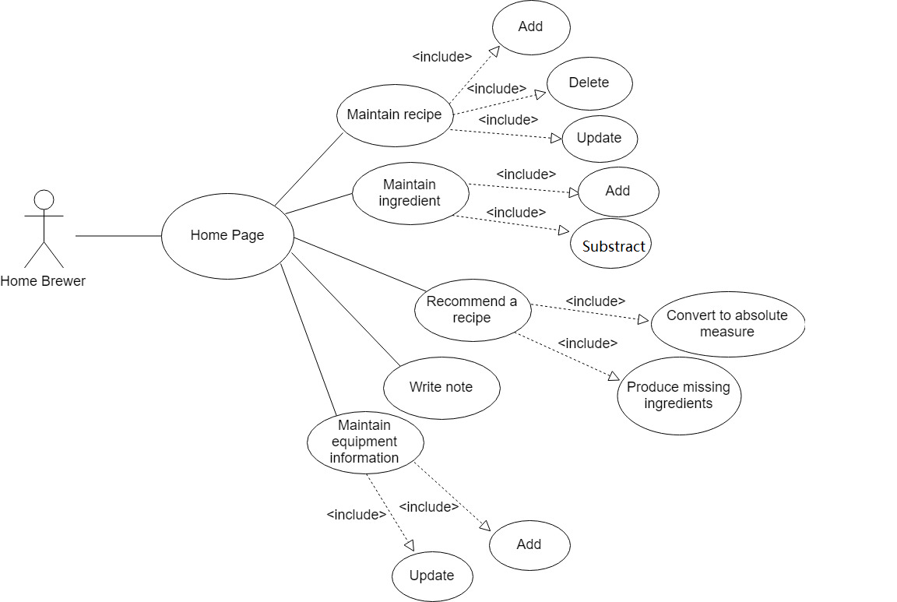
Also, such design satisfies more cohesion and less coupling, which makes the system more manageable.

Overall description

Use case diagram and class diagram

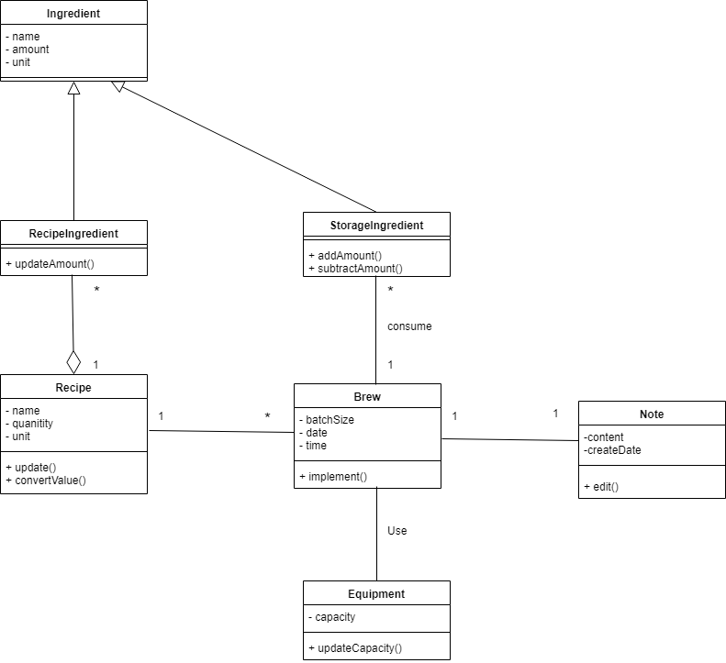

Design model
The MVC layered model with three tier is chosen in this design, where we get subsystem for application logic, interface and database.

The reason to use the model is because, for one thing, the layered model supports the incremental process, for another, since our software is designed in as an interactive system, so the choice of the MVC will be more suitable.

System architecture

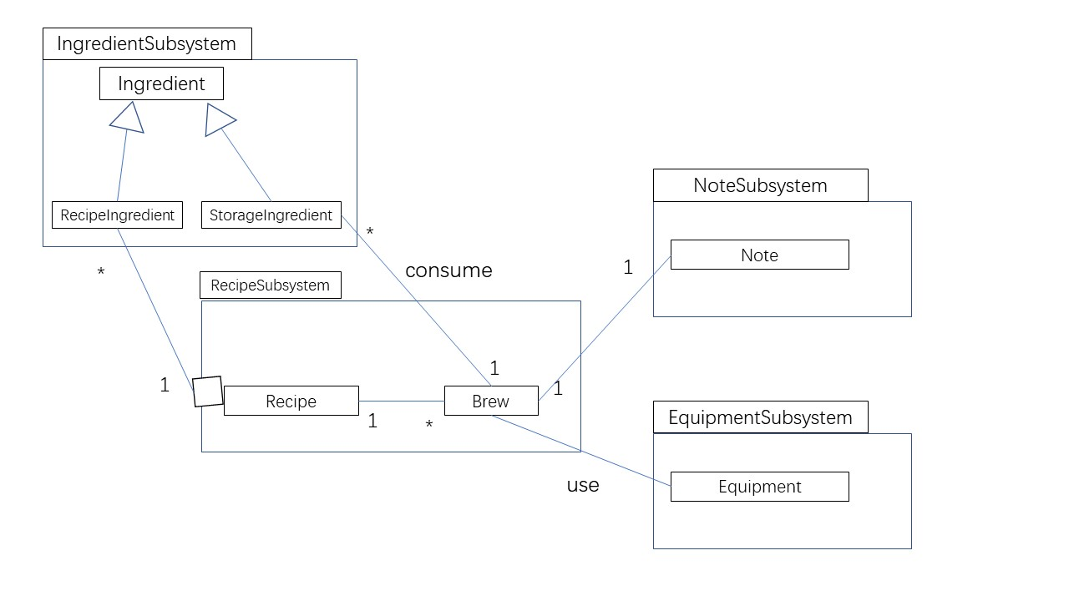

Our design contains three sub-systems. They are recipes, ingredients and equipment with the conservation of the persistent data. All of the three subsystem satisfies our design in the class diagram and satisfies cohesion and coupling.

System architecture

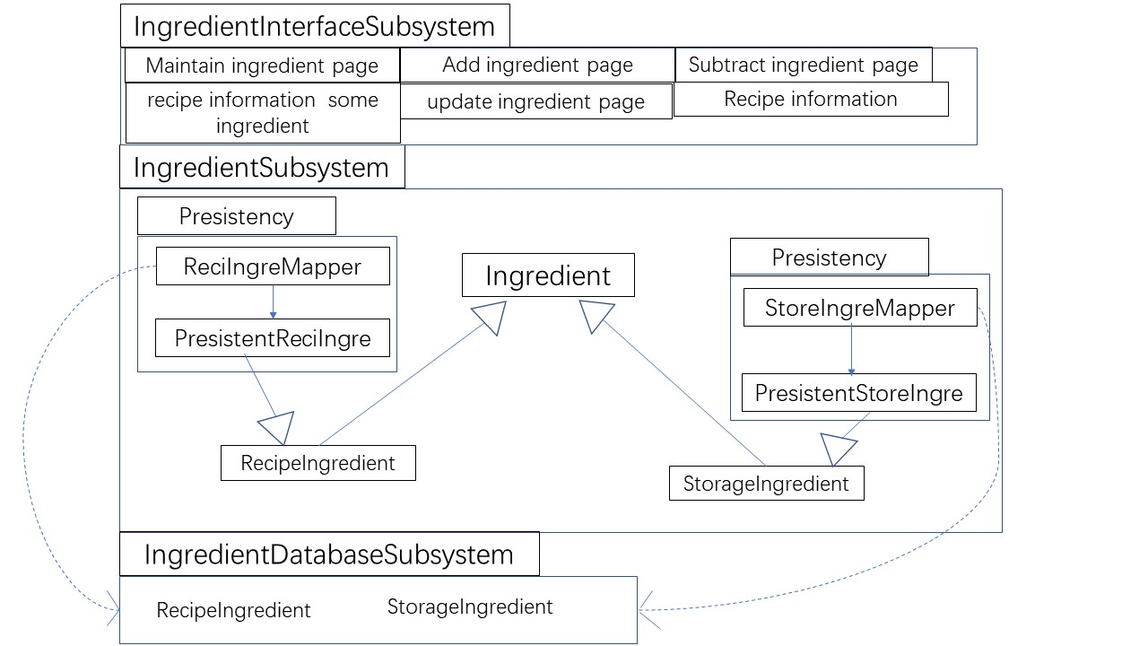
Ingredient Subsystem

Description
This subsystem contains Ingredient component inheritance of RecipeIngredient and StorageIngredient. Also, the database consists of the storage data for RecipeIngredient and StorageIngredient.

Database
recipe_ingredient:
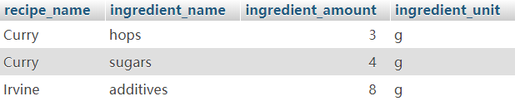

storage_ingredient:
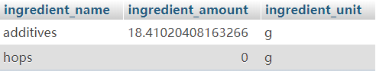

The database table for the recipe_ingredient contains the element of recipe_name, ingredient_name, ingredient_amount and ingredient_unit.

The database table for the storage_ingredient contains the element of ingredient_name, ingredient_amount and ingredient_unit.

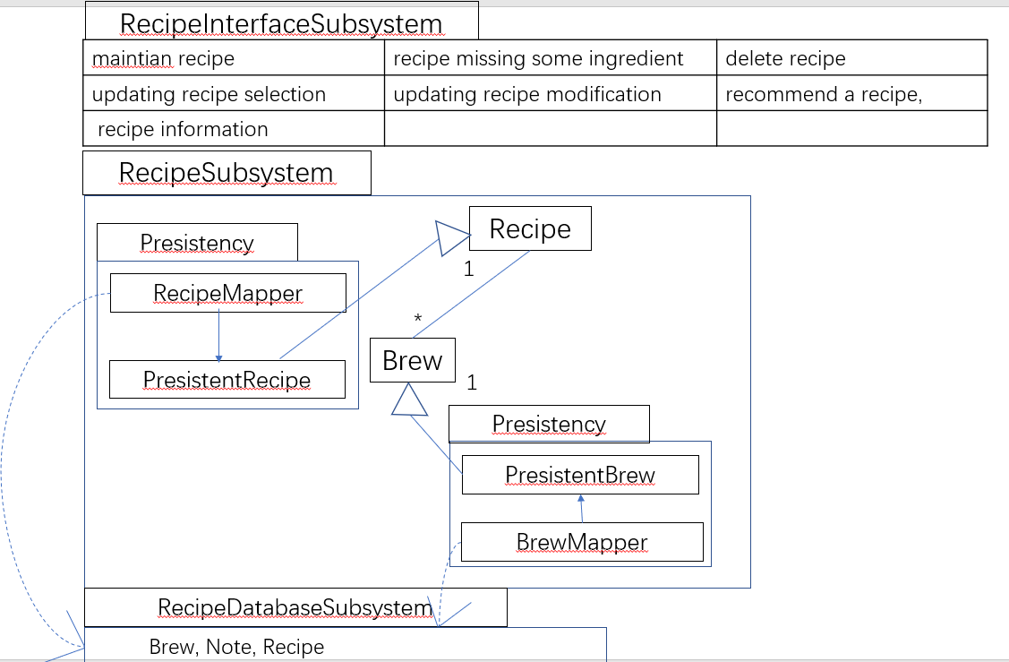
Recipe Subsystem

Description
This subsystem contains Brew, recipe and note component. Also, the database consists of the storage data for Brew, Recipe and Note.

Database
The database table for the recipe contains the element of name, quantity, unit, value.

The database table for the brew contains the element of brew_id, batch_size and batch_unit, date, time.

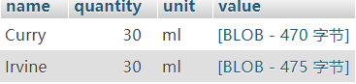
recipe:

brew:
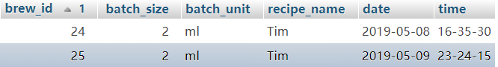

Equipment Subsystem
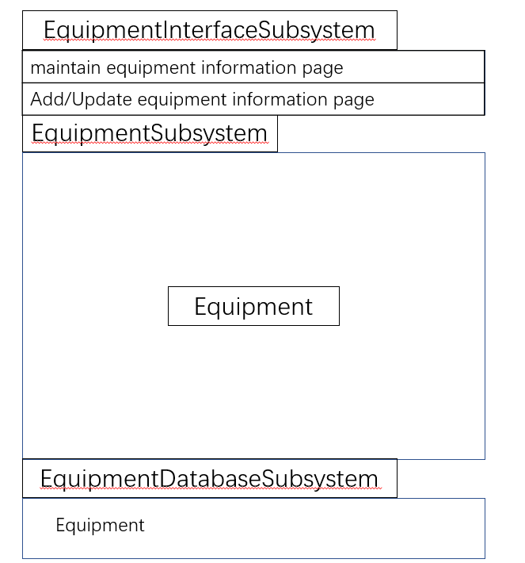

Description
This subsystem contains Equipment component. Also, the database consists of the storage data for Equipment.

Database
The database table for the Recipe contains the element of capacity, unit.

equipment:
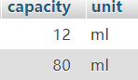

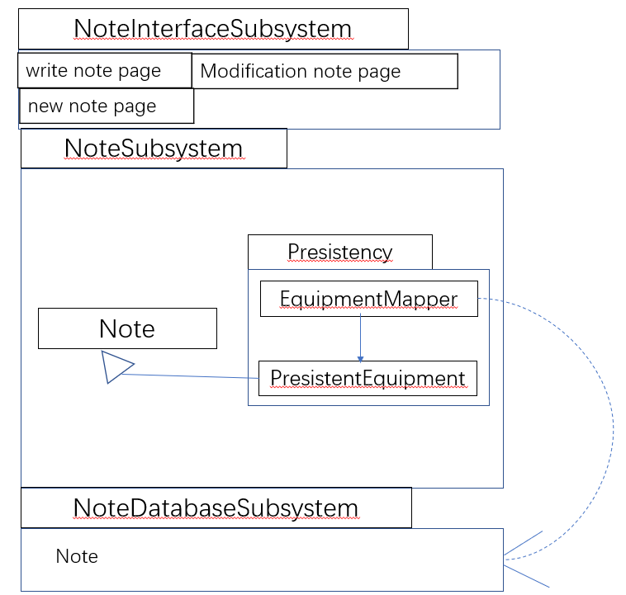
Note Subsystem

Description
This subsystem contains Note component. Also, the database consists of the storage data for Note.

Database
The database table for the Recipe contains the element of brew_id, content, date, time.

note:

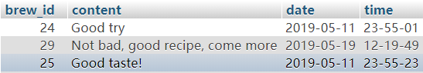

Assessment

Stability
The system based on the architecture is somewhat stable. Since the MVC model could make sure that the model part would not depend on the view or controller, which is somewhat stable, and not easy to be influenced, and this satisfies the cohesion.

For coupling, the four subsystem is somewhat independent to each other. The recipe and the ingredient could act at different role, also the note and the equipment is independent to each other.

Reusability
The ingredient component could be used in another place, since the recipe could be implemented by both the recipe

ingredient and the storage ingredient and that is one of the advantages of the layered model.

Scalability
This architecture is easy to extend, since the layered model support the incremental process and the layer can be replaced by another one if the interface is not changed.

The MVC model is easy to extend, since the model does not depend on any viewer and controller.

Alternative design (optional)
None

More considerations
None

Appendix
None

